

Machine Learning-Music Recommendation

Progress Report

| Roll No. | Name of the Student | Name of the Program |
| --- | --- | --- |
| AU1940142 | Shail | ML |
| AU1940267 | Sahil | ML |
| AU1940034 | Varun | ML |
| AU1940109 | Jap | ML |

**Features visualization**

We performed exploratory data analysis and feature visualization. In feature visualization we have developed a correlation matrix and the correlation heat map. We have also plotted a graph of the correlation between popularity of the song and other variables. The reason for choosing popularity is because most of the users are very much attracted to the best songs of the month, year, decade. This might be an important feature which could drive our model. Since correlation only exposes the linear relation we have been able to plot the non linear relationship between the variables too in the form of a graph.

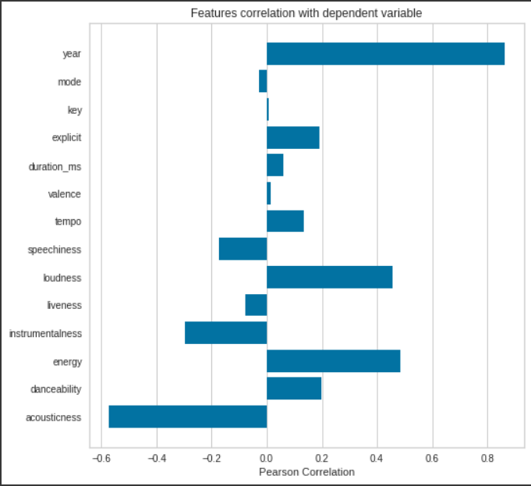

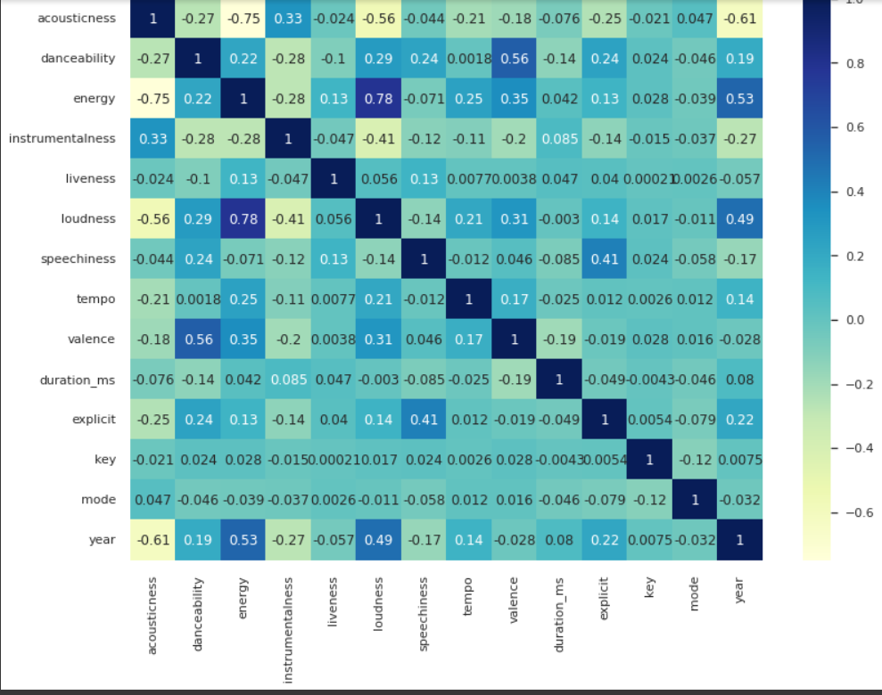

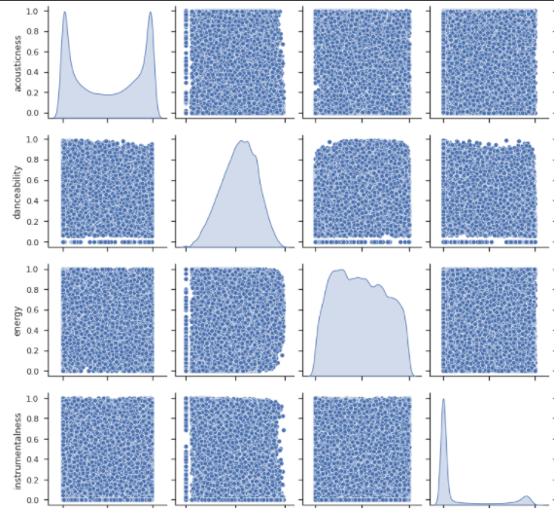

**Future work**

Based on the relationship between the variables we will now be reducing the redundant variables in order to decrease the redundancy of the dataset.

Apart from this we will be scaling down the variables to the same range as the other variables so that the model does not assign high importance to a higher scale variable.